Space complexity:

Space complexity refers to the total amount of memory space used by the algorithm/program , including the space of input values for execution.

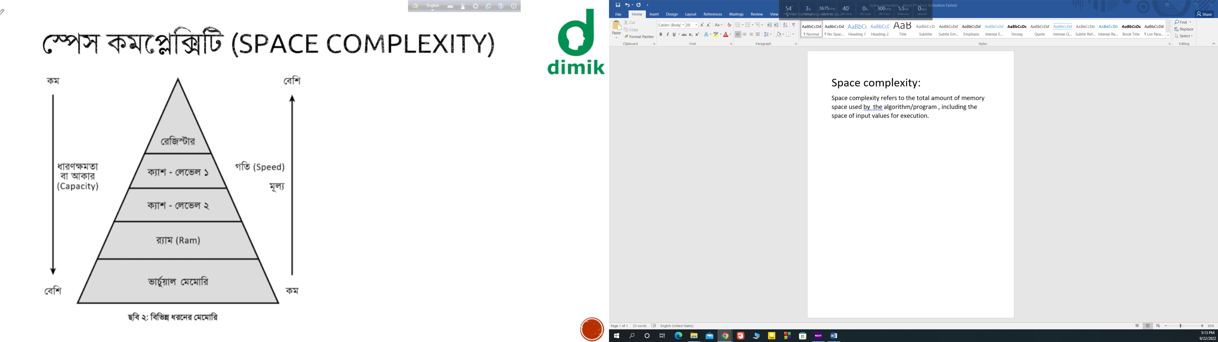

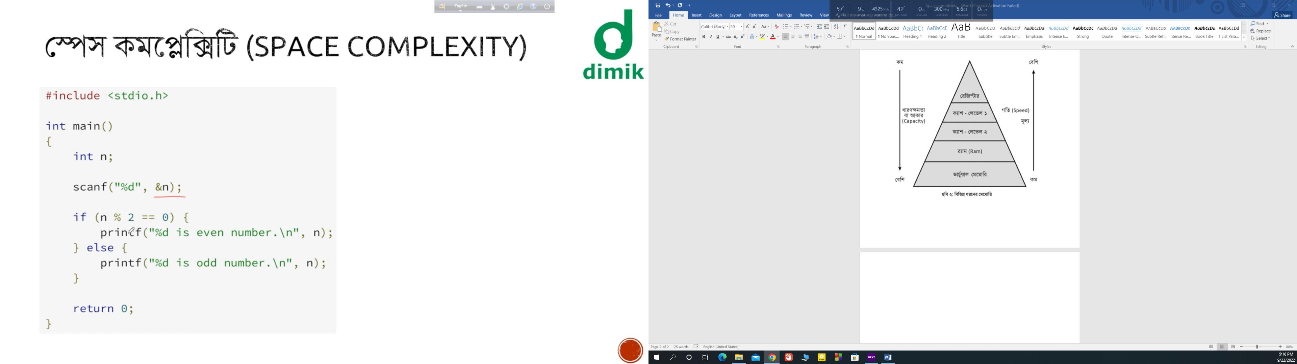

Time complexity : O(1)

Space complexity : O(1)

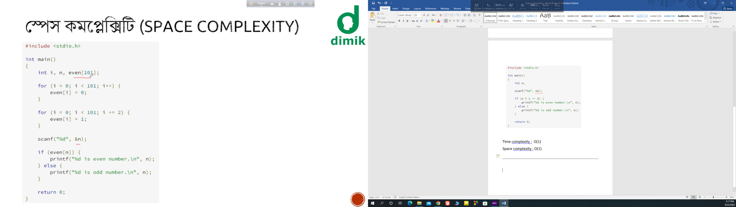

Time complexity: O(n)

Space complexity : O(n)

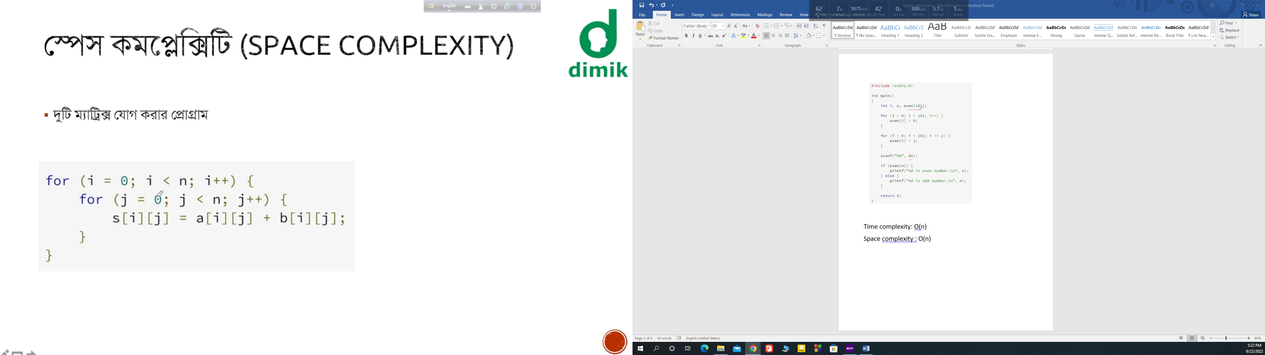

Time complexity : O( n^2)

Space Complexity : O(n^2)